L.A.R.S. Fox Hunt of 11 September, 2004
By Stanley Baker KD4ERF, the “elusive red fox”

As of 6:30 p.m. of September 10, 2004 the fox battery was placed on slow charge to be ready for the next day. The fox box was programmed with the KD4ERF call sign in hopes that the problem of having the call sign auto-erase from the unit would not happen again. The unit was checked out using a mobile 2-meter antenna and was operating normally. The unit was powered off and placed in the yellow bucket for transport to the lair. The 4-element beam antenna, made from plans using camouflaged metal arrows on a hollow, square aluminum bar, and using a home-brew impedance matcher made from brass tubing and flexible, plastic tubing, was taken out of storage and prepared for mounting on its aluminum, square, U-bar pole which was designed for support by a slick, heavy-duty camera tripod for portability.
Because of the location that had been chosen, the rotating base for the antenna and the fox box array was not prepared for use as it would have made the chosen location a little too difficult.
At 8:30 a.m. on Saturday, September 11, 2004, the battery was taken off charge and packed in the yellow bucket with the fox box and other items. After a brief breakfast a home, the equipment was loaded in the Jeep and the fox departed for the chosen lair shortly after 9:00 a.m. Arriving at the chosen lair it was discovered that the door to the lair was not accessible. This was a major problem as a new lair had to be found in only a short time. Hence at approximate 9:25 a.m., another lair had to be found very quickly. After making a couple of phone calls on the cellular phone, a site was available if the equipment could be transported to that location in time to begin barking at 10:00 a.m. Rushing to that location, the fox box was quickly unpacked and setup on a Ford tractor parked beside the maintenance barn on the Bennett Center off West Fifth Street. The antenna was pointed in a roughly East-West direction and the fox box was switched on at 10:59 a.m. on 147.550 MHz The signal was bouncing off the side of the fieldhouse currently used by the Y on that campus.
As only two fox crews were heard to be hunting, the fox decided to make tracks to the London Shopping Center where the hunt was beginning. This would take the fox’s Jeep to the hunters and reduce the chance that the hounds would see it from West Fifth Street. Upon arriving the fox played ignorant and asked the hounds, “ Where is the fox hunt, today?” and then joined in the hunt.

* * * * * * * * * * * * * * * * * * * * * * * * * * * * * * * * * * * * * * *

L.A.R.S. Fox Hunt of September 11, 2004
By Peter Rock KJ4ND, one of the hounds

It was a clear, early Fall day for the fox hunt . After getting my antennas and other things ready in the big van, I headed of for the fox hunt. I got to the usual site near Tractor Supply a little before 10am, and no one else was there at that time . I got my antennas out and waited for the fox to come on. I called a couple times on the repeater, but no answer.
At very close to 10am the fox came on loud and clear. I didn't need to use the pole to hear this one. It was over half scale on the mobile and on the ht. I took a couple readings, and got very close to about 350 degrees, toward the closer end on Wal-mart. Soon after, Eddie K4XXX and Dave KG4LGA, showed up and Eddie took some readings, and got the same direction as I did. Of course, we figured that it could also have been some reflections off the buildings, so we decided to drive around the back of Wal-mart, on Myers-Baker Road, and see what we got there.
When we took some readings on the hill there, it was about 40 degrees, and strong enough that we had to use an attenuator on the antenna to get the direction. We plotted it on the map, and that had it going over to Rt. 638 , near Marvin’s AG4RE.
Of course, it could be anywhere along that route, and since it was so strong, it probably was close by. We drove onto West Fifth St., heading into town (North), and as I was getting by Sue Bennett College, the signal was off the scale, even with the 80 db attenuator on, so I parked there, and we went on foot from there.
We even had a little signal on the ht's with their antennas off, so it had to be very close. By using my body as a shield, there was a big difference in the "front to back " ratio with several bars difference on the ht. Using this method, several times over, We were able to very quickly walk to where the fox was. And would you believe that it was on an old tractor?
Stanley's (KD4ERF) homemade was oriented about east /west , and that may be why the signal came up so quickly, since we were crossing the path of the beam .
So it was a quick hunt, and Stan said he had to come up with that location at the last minute.
Looking foward to more.,
73's
Peter KJ4ND

Pictures of the Fox Hunt - Courtesy of David Lemley KG4LGA with a
group photograph by the Bennett Center sign by G.H.W. “Buddy” Westbrook, L.A.R.S. member and a representative of the Bennett Center

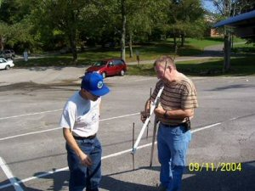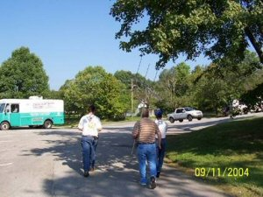

Peter KJ4ND and Stan KD4ERF Eddie K4XXX, Stan KD4ERF, and
look at the fox beam antenna Peter KJ4ND return with the fox

S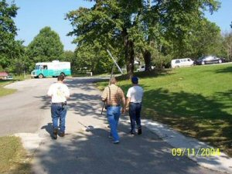 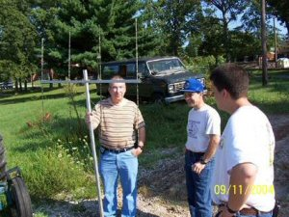

With fox in hand, the hunters The hunters discuss the “kill”
return to their vehicles… with the fox…
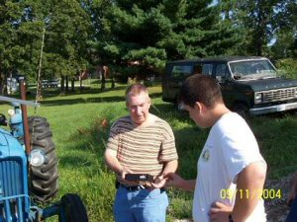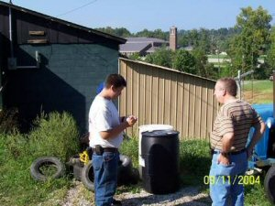

Stan KD4ERF and Eddie K4XXX Stan KD4ERF watches Eddie
look at the Fox transmitter… K4XXX take a reading on the fox

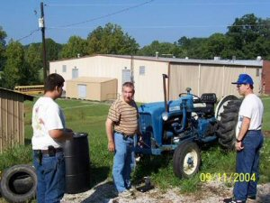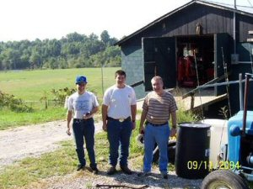

Eddie K4XXX, Stan KD4ERF, Peter KJ4ND, Eddie K4XXX and
and Peter KJ4ND discuss the Stan KD4ERF view the fox…
fox location…
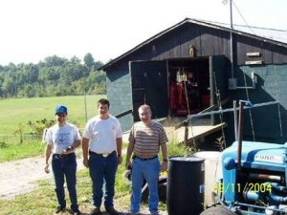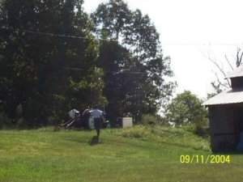

Peter KJ4ND, Eddie K4XXX This views the fox location from
and Stan KD4ERF discuss the the road leading to the fieldhouse
antenna orientation of the fox…
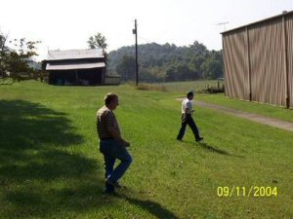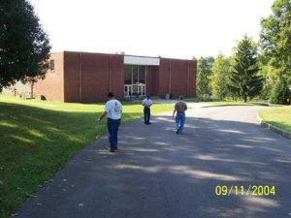

Stan KD4ERF watches the hound The hounds check out the area
search near the fieldhouse… around the fieldhouse…

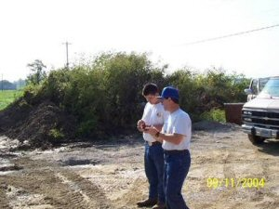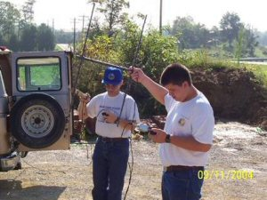

Eddie K4XXX and Peter KJ4ND Eddie K4XXX (no hat) and
check readings from the top of Peter KJ4ND (blue cap) check
the hill on Meyers-Baker Road… readings on Meyers-Baker Road

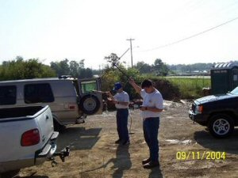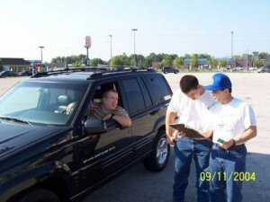

Peter KJ4ND and Eddie K4XXX Stan watches Eddie and Peter
check readings pointing to rt. 638 discuss the next move…
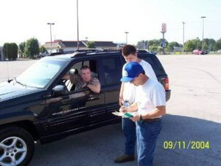

Stan and Eddie watch Peter Stan KD4ERF and Eddie K4XXX
plot vectors on the map… watch as Peter KJ4ND makes a
decision based on map vectors…
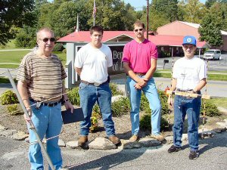

Stanley Baker KD4ERF, a.k.a., the “elusive red fox”,
Eddie Lemley K4XXX, David Lemley, and Dr. Peter Rock KJ4ND
pose for a L.A.R.S. Fox Hunt picture by the Bennett Center sign near
the location of the fox. Photograph by G.H. W. “Buddy” Westbrook, a
member of L.A.R.S. and a representative of the Bennett Center.

